**Assignment**

Kirinyaga County Spatial Plan (2015-2025)

**Client:**

County Government of Kirinyaga ,

**Period:**

May 2016- 2024

**Status:**

Complete and Approved

**Project Outputs:**

1. GIS based digital Maps
2. County Spatial Plan with;

* Land Use Plan,
* Colonial Villages Plan (110 informal settlements),
* Informal Sector Plan
* Housing Plan,
* Traffic and transportation Plan,
* Water resources development and drainage plan,
* Environmental Management Plan,
* Solid waste Management plan,
* Social Infrastructure Plan,
* Zoning Regulations,
* Utility Services Plan,
* Economic Plan, Disaster Management Plan,
* Swamps Management Plan.

The land use plan is an integration of three development strategies; the Agricultural Development Strategy, Urban Development Strategy and Eco Tourism & Conservancy Strategy. The strategies are based on the county’s economic base, potentials and opportunities. It is envisaged to provide a path towards achieving prosperous county development.

**Urbanization Strategy**

It aims at driving the County’s socio-economic development by promoting growth in urban centres by identifying and developing a planned network of designated functional centres across the county. It advocates for strong rural-urban linkages.

**Tourism and Conservational Strategy**

The strategy promotes establishment of tourism zones around existing facilities, Promotion of tourism sector as well as development of new tourism niches including county tourism circuit, Adventure tourism destinations eg water sports etc.

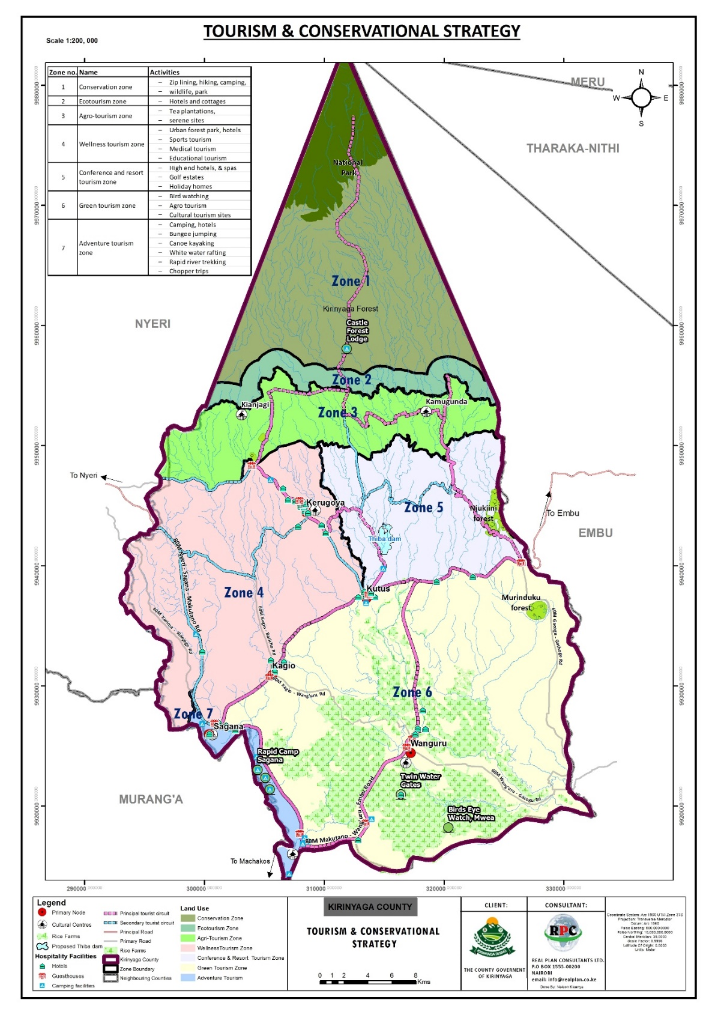

**Agricultural Development Strategy**

The strategy earmarks the County into zones most ideal for the production of various crops. It seeks revival of declining key agricultural practises such as coffee and cotton farming. It also harnesses the emerging better farming practices.